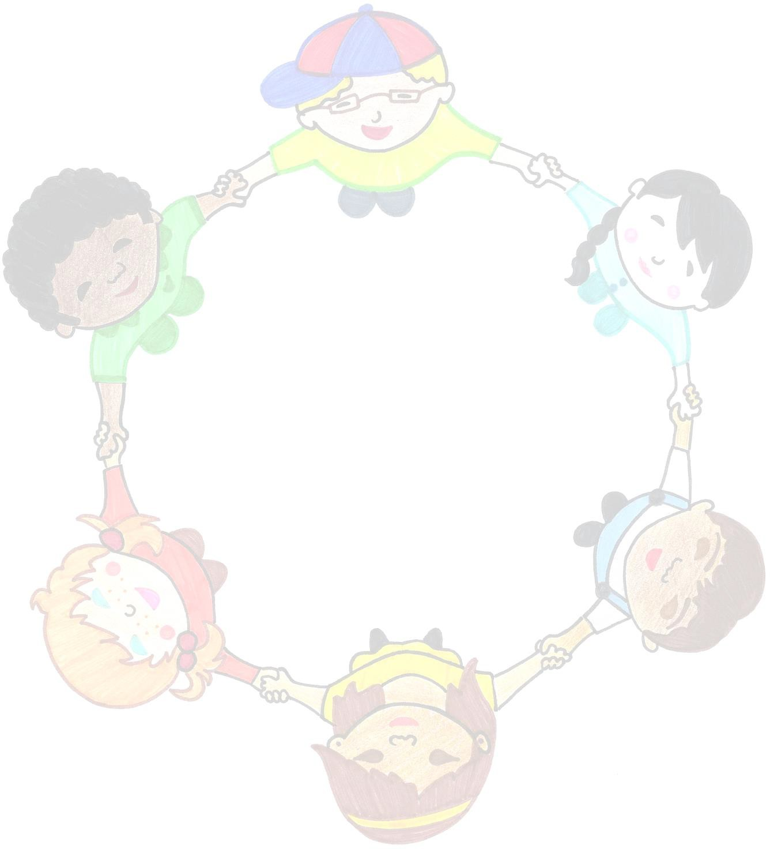FAMILY HANDBOOK

**THE PLAYHOUSE PRESCHOOL, INC**

*65 South St., Suite 100*

*Hopkinton, Ma. 01748*

*License # 9015442*

*508-497-9140*

*508-533-4522*

*Owned and Directed By: Ida Termini*

*Licensed By:*

*Massachusetts Department of Early Education and Care*

[www.playhouse-preschool.com](http://www.playhouse-preschool.com/) Version 1.12

8/11/14

*Table of Contents*

NOTICE OF CHANGES 2

STATEMENT OF PURPOSE 3

PROGRAM INFORMATION/CURRICULUM 3

CLOSURE LIST 4

MAKE UP POLICY 4

PARENT PARTICIPATION AND COMMUNICATION 4

PHONE CALLS/CANCELLATIONS 4

GUIDING BEHAVIOR 5

REFERRAL SERVICES 5

HEALTH CARE POLICY 6

ADMINISTRATION OF MEDICATION 7

PREVENTION OF ABUSE AND NEGLECT 8

TOILET TRAINING 9

ITEMS FROM HOME 9

SNACK TIME (We are a peanut/tree nut free school) 9

TRANSPORTATION POLICY 9

TRANSITIONING STUDENTS 10

FIRE DRILLS AND EVACUATION PLANS 10

MAINTENANCE OF CHILDREN’S RECORDS 10

FEE SCHEDULE AND THE PLAYHOUSE TERMINATION POLICY 11

LATE PICK UP POLICY 11

FAMILY TERMINATION POLICY 12

ORGANIZATIONAL INFORMATION 13

PROBLEM SOLVING/GRIEVANCE PROCEDURE 13

# NOTICE OF CHANGES

This handbook may be updated periodically. Please check the website for newer versions. If there are any substantial changes in either fees or policies, you will be notified at least 30 days in advance.

Please retain this handbook for future reference.

# STATEMENT OF PURPOSE

Our mission at The Playhouse Preschool is to offer a developmentally appropriate, process- oriented program for all children ages 2 months to 7 years. We do not discriminate on the basis of race, sex, religion, cultural heritage, political beliefs, national origin, marital status, sexual orientation, or disability. We do not require children to be toilet trained to join our program. We accept children with developmental delays as long as we have the training and equipment to provide the best care for the child. We embrace the philosophy that young children learn best through active play and exploration in a safe, nurturing environment. Your child’s cognitive, language, social/emotional, and fine and gross motor skills will emerge and grow at their own pace as s/he participates in a balance of child-directed and teacher- facilitated activities. Our teachers will provide a classroom of stimulating learning centers, small and large group activities, snack and clean-up time, toileting and hand washing assistance, diaper changes if necessary (please send a supply), outside play, and a group meeting time with songs, games, and stories.

# PROGRAM INFORMATION/CURRICULUM

The Playhouse Preschool Inc. isownedandoperatedby IdaTermini, who residesin Medwayandisthe on-sitedirector andone of our leadteachers. Our center is openyear round; our preschool program is offered Mondaythrough Friday, offering an a.m. andp.m. classfor children 2.9 years to 5yearsofage. Ourtoddlerprogramisoffered eachmorning,9:00 to12:00. We also offer early

drop-off at 7:30 a.m. andextended days until 5:30 for all ages. Our infant program is offered Monday through Friday on a full or part time basis.

We have adopted The Creative Curriculum (TCC) for children 0 – 5. This curriculum strongly recognizes theneedforattachment andnurturance inorder for children to learn. Relying on child development theories and current research, our teachers can chart your child’s individual goals and objectives, observe and record their behavior, and utilize this information to plan activities and complete progress reports.

Our school is licensed by the Department of Early Education and Care and our teaching staff is also certified by E.E.C. Parents may contact E.E.C. for information regarding our regulatory compliance history (10 Austin Street, Worcester, MA – 508- 798-5180). We recommend you visit our school during our regular hours. You may call to schedule an appointment with Ida (508-497-9140 or 508-533-4522). Should you decide to enroll your child, a non-refundable fifty dollar registration fee per family is required. Parents can pick up an Enrollment packet anytime during our regular hours and will be able to sign up for a customer portal login for registration, billing and updating contact information.

# CLOSURE LIST (2014-2015)

We are closed for the following Holidays and Breaks:

Last week of August 08/25/14-08/29/14 Labor Day 09/01/14

Columbus Day 10/13/14

Thanksgiving Break 11/27/14-11/28/14 Holiday Break 12/24/14-01/01/15

President’s Day 02/16/15 Patriot’s Day 04/20/15 Memorial Day 05/25/15 Fourth of July 07/04/15

# MAKE UP POLICY

We no longer offer any make-ups.

# PARENT PARTICIPATION AND COMMUNICATION

The Playhouse values open communication and a consistent connection between the child’s family and our teachers, as we become partners in your child’s education. We welcome your

suggestions and feedback. Our goal is to get to know and care for the whole family. Parents are welcome to visit our classroom at any time. Our door is always open. Please walk your child into and out of school at arrival and departure times. We appreciate any information about your child as s/he arrives each day and are happy to chat about how the school day went at departure time. Parents can request a phone call or a conference any time with their child’s lead teacher for more in depth questions and concerns. Conference times are available each Monday from 8:00 – 1:00. Our parents will receive a written progress report in November and April, followed by a conference if either the parents or the lead teacher requests one.

We invite our parents to spend time in our classroom during arrival time and enjoy meeting siblings and extended family. We encourage parents to share their time and talents through activities such as storytelling, cooking, music, arts and crafts, or just playing in their child’s class.

# PHONE CALLS/CANCELLATIONS

Feel free to call school anytime but please remember that the answering machine is on during school hours. We’ll listen to the messages periodically and return your call ASAP.

The Playhouse will make every attempt to be open during poor weather conditions even if Hopkinton schools are closed. If we cannot get teachers to school safely, we will notify you that we cannot open. No make-ups will be allowed for these days.

If conditions worsen during the day, you may receive a call to pick your child up early.

# GUIDING BEHAVIOR

Because our teachers are sensitive to the stages of development, they understand that the children are at school to develop many social skills such as making friends, expressing feelings, and sharing. We help the children develop self- esteem, self-control, and empathy in several ways.

First, the teachers set the tone of the classroom by being positive examples of cooperative relationships. Second, through careful set-up of the inside and outside environment, the children have enough space, equipment, and teacher attention to keep them safe and diminish conflicts.

Third, the children are gently and consistently reminded of the expectations of our preschool and are encouraged to express their needs and feelings in appropriate ways. Removing a child from the classroom is rare and only used if the child has not responded to repeated verbal limits and continues to harm him/her-self, others, or the environment. If this becomes necessary, the teacher will accompany the child to a quiet spot to talk about what happened and help the child calm down so that s/he can return to the classroom quickly. Child will be removed for no more than one minute per year of age.

The Playhouse Preschool prohibits the following behaviors: spanking or other forms of corporal punishment of children; subjecting children to cruel or severe punishment such as humiliation, verbal or physical abuse or neglect; depriving children of meals or snacks; force feeding children; disciplining a child for soiling, wetting, or not using the toilet; forcing a child to remain in soiled clothing or on the toilet; confining a child to a swing, high chair, crib, playpen or any other piece of equipment for an extended period of time in lieu of supervision. Any unusual or excessive practices for toileting are prohibited.

# REFERRAL SERVICES

If it is necessary to refer a child for mental health, social, educational, or medical services, the Playhouse director will provide a written statement to the parents indicating the reasons for the referral, summarizing the recorded teacher observations, and describing what efforts have been made to accommodate the child’s needs. The Playhouse director will help the parents contact the Special Education director in their town and assist the parents in any way with observations, written progress reports, and attendance at meetings. A written record of the parental

authorization, referral and conference results will be kept in your child’s file.

Our referral plan proceeds as follows:

1. A member of the teaching team approaches the director with their concern.
2. Either the lead teacher or the director observes and records the child’s interactions on three different occasions.
3. The results of the observations are discussed at our staff meeting.
4. The director informs the parent(s) of the issues and recommends an outside evaluation, assisting the family in making contact with the Early Intervention consultant or Special Education director and assists the parents during this process.

Written parental authorization is required for referrals to be made and information to be shared.

# HEALTH CARE POLICY

One of the most important concepts that we teach our children is sharing and, unfortunately germs are one of the things that they share! Part of our responsibility in providing a safe environment for our children is implementing a plan for infection control. We take many measures to minimize the spread of illness and one of these is the occasional exclusion of children who have communicable illnesses. We balance this with the realization that Families need to work.

Because we are concerned with the health and well-being of all our children and staff, a child will be sent home if he/she has a combination of the following symptoms*:

-Lethargy or irritability -under arm temperature of 100 or higher**

-Chronic, persistent coughs -green or yellow mucous

-Diarrhea -vomiting

-Rash -lack of appetite

-Pain or discomfort -flushed or pale appearance

-Abnormal breathing -irritated, red-rimmed eyes

*A child may be admitted if your pediatrician provides written documentation that the symptoms that your child exhibits are caused by a non-contagious condition.

**Fever: Because fever is such a vague symptom, a child will not be excluded for fever alone UNLESS the under arm temperature is 102 or higher OR the fever has persisted for three days. In these circumstances a child must be fever free without medication OR we must receive written documentation from your pediatrician stating that the fever is not due to a contagious condition. If your child is an infant, we will contact you if the under arm temperature is 99 or higher.

In the event that we need to call you mid-day to pick up your child from the center, please arrive within one hour or send an authorized person (listed on your emergency contact form) to pick up your child. If your child needs to visit the doctor due to illness, or is picked up to go home due to illness, he/she may not return that same day.

Children sent home with a fever may return once they have been fever-free for 24 hours without medication. Children absent from the center with a contagious disease will not be allowed to return to school without a note from a physician stating that the child is not contagious.

If you believe that your child is too ill to participate in all of the day’s activities, including outside play, your child should not attend for the day. In order to maintain proper ratios, we are not able to keep a child inside unless we are waiting for the child to be picked up to go home. We understand that frequent absence puts a stress on your work situation, but we need to insist on your cooperation to keep our children illness-free to the extent that is reasonable. Please keep your child home if he/she is ill.

**Health Care Consultant Caitlin Theodorou**

**11 Nazneen Circle**

**Hopkinton, MA 01748**

**508-435-9363**

**Emergency Numbers:**

**Fire, Police, Ambulance – 911**

**Milford Regional Hospital – 508-473-1190 Poison Control Center – 800-682-9211**

# ADMINISTRATION OF MEDICATION

We cannot administer any medication without the proper authorization from parent or guardian and physicians. We need a physician’s permission, as well as the appropriate “Authorization for Medication” form (provided by The Playhouse Preschool) signed by the

parent in order to administer any medication. Center policy requires that all medications (other than emergency meds) be given by staff trained in the proper administration of medication.

For prescription medication, the medication must be in the ORIGINAL prescription bottle/container. Medication cannot be mixed with food or drinks unless the physician provides these instructions in writing. In this case, center staff must mix the meds with the food or drink just before giving it to the child.

Non-Prescription Medication: A written note of permission from your pediatrician must indicate the following: Child’s name, Current date (standing orders are valid for one year), Exact Medication Name, Dosage Information, Time and Reason to administer medication. We are not permitted to share medication and the center is not permitted to provide medication. Medication should be given directly to staff, not placed in their backpack, lunch box, etc. If we have a standing order for medication, we will always attempt to contact you before administering medication.

Medication can only be given per a physician’s instructions. For OTC medication, we must follow the instructions on the label. We cannot administer medication contrary to these instructions unless we have a doctor’s written instructions to do so.

If a child has been hospitalized, absent due to illness for three consecutive days, has been treated for a serious injury, or has had any type of surgery, a physician’s note must be provided to the center allowing the child to return to childcare. The note must state that the child can participate in a typical childcare day, and/or state any restrictions that should be in place.

In accordance with our regulations, infants will be placed in the “back to sleep” position when it is time for naps. There will be no exceptions to this policy unless we are instructed otherwise in writing by your child’s pediatrician.

Following the proper guidelines for infection control and sanitation, children will be given the opportunity to brush their teeth after lunch time, in accordance with the preferences of

their parents.

## Medication Administration Policy:

1. The parents must provide all medications for their child.
2. No educator will administer the first dose of any medication except under extraordinary circumstances and with parental consent. (NO EEC regulation states that you cannot give first dose of any medication – other than those used for emergency situations (i.e. - an epi-pen, diastat, etc.)



1. Regulation 7.11(2)(i) states consent is required
2. All prescription medications must be in original containers with the original labels. Over the counter medication must be in its original packaging.
3. The teacher must not change the medication directions without the written consent of the licensed health care practitioner.
4. All medications will be stored out of reach of children and under proper conditions for sanitation, preservation, security and safety. The EPI pens will be immediately available for use.
5. All unused, discontinued or outdated medications will be returned to the parents and documented in the child’s record. When this is not possible, the medication will be destroyed by the Director, following the DPH recommendations.

# PREVENTION OF ABUSE AND NEGLECT

The Playhouse Preschool will protect children from abuse and neglect while in the program’s care and custody. Our prevention of abuse and neglect policy is printed in our Employee Handbook and Parent Handbook. The DCF number is located next to our telephone. Everyone on our staff is a mandated reporter and must, by law, report suspected child abuse or neglect.

The procedures for reporting include:

1. The staff member will inform The Playhouse director of the suspected abuse or neglect (suspected parent/adult or another staff member).
2. The director will immediately report the suspected abuse or neglect to the Department of Childcare and Family Services in Framingham; filing a 51A report.
3. The director will notify the Department of Early Education and Care after filing a 51A report or after learning that a 51A report has been filed against The Playhouse.
4. The Playhouse staff has the right to discuss their suspicions with a DCF case worker, even if a 51A has not been filed.
5. The Playhouse staff will cooperate in all investigations of abuse and neglect, providing information to the DCF and ECC as requested.
6. An allegedly abusive or neglectful staff member will not work directly with children until the ECC completes its investigation and gives permission for the employee to return.

# TOILET TRAINING

We do not require that your child is potty trained to enroll at the Playhouse.

We will follow the parents’ lead and support this process when your child is at school. Please be aware that the activity level at preschool can distract your child from responding to an urge to use the potty, more so than at home. We also request that your child be dressed in “user-

friendly” clothing as much as possible, avoiding onesies, overalls, and tricky buttons to support potty success. Please send in several complete changes of clothing during this period of learning. We always have extra to loan if the backpack is empty.

# ITEMS FROM HOME

Please send your child to school in play clothes. Please send in an extra set of clothing and diapers/pull-ups if necessary for your child. The clothing will be stored in his or her backpack and the diapers will be added to our supply next to the changing area.

Except for soft, quiet, “Comfort” toys for rest time, toys should not be brought from home unless needed for a classroom activity. All items worn or brought to school should be clearly labeled. The Playhouse Preschool is not responsible for lost or broken items brought from home. Toy guns, swords, other weapons or electronic toys are NOT welcome at our school.

# SNACK TIME (We are a peanut/tree nut free school)

Please send an individual snack (nut free) for your child to be served at the morning snack each day your child is at school. If your child is here after 2 pm please send in an additional snack for him/her for the afternoon snack. (In the event you forget to pack a snack we will have extra snacks on hand to serve your child.) We do supply water and/or 100% juice during snack time. We are a peanut/tree nut free school and routinely check labels when purchasing any snacks. We are sensitive to those with allergies and are willing to work with parents so that snack time meets everyone’s needs.

We don’t hesitate to call the parent when in doubt about an ingredient. Parents are welcome to send in special treats for birthdays and holidays. Please check the listing of class allergies on the Parent Information Board. The Playhouse Preschool does not use peanut butter during snack or art projects. Parents also need to check with their child’s lead teacher before supplying a special snack.

# TRANSPORTATION POLICY

You are responsible for driving your children to and from The Playhouse. It is your responsibility to make any necessary carpool arrangements for your child and to inform The Playhouse in writing if another adult is picking him/her up. Forms will be made readily available for you to fill out and sign. You are required to walk your children into and out of the building (please hold hands in the parking lot) and ensure that they are signed in and out daily. Please bring your child into the proper classroom and into the care of a teacher before leaving. The Playhouse is not responsible for children left in an empty classroom or allowed to circulate throughout the center at drop-off or pick-up time. If you need to walk through the center at drop off or pick up, please be sure that your child is in the proper classroom with the teacher

aware that he/she is there, or is with you. Please call if your child will be absent or if there will be a change in his/her arrival/departure time.

Kindergartners attending the before/after program in Hopkinton will be transported to/from the Playhouse to/from the Center School by the public school bus.

# TRANSITIONING STUDENTS

As your child approaches the age to transition to the next class (infant to toddler, toddler to preschool), the lead teacher will discuss your child’s readiness with you. We encourage you to talk about the change with your child at home in a low key manner. With your permission, your child will visit the new class with his/her teacher for 2 hours per week, leading up to the date of the transition. The teacher will also meet with you to let you know how your child is doing in there new classroom.

# FIRE DRILLS AND EVACUATION PLANS

The Playhouse Preschool will practice a fire drill monthly.

The children and teachers will exit (exit doors will vary) the building and walk quickly to our fenced in playground. The lead teacher will carry a cell phone to contact the fire department. They will also bring the attendance sheet to make sure all the children and teachers are accounted for.

If notified by the Police Department to evacuate the building due to a natural disaster or other emergency, your child will be bussed to the Elmwood School gymnasium and you will be notified immediately by the director or designee, and will be expected to pick up your child in a timely manner.

In the case of a power outage, loss of heat or loss of water, the director will notify you to pick up your child as soon as possible. You will be notified if any power outage, loss of heat or loss of water lasts for more than 3 hours.

The school is equipped with carbon monoxide detectors.

# MAINTENANCE OF CHILDREN’S RECORDS

All information contained in a child’s record is privileged and confidential. The Playhouse will not distribute or release information in your child’s file without your written consent. You may request access to your child’s record. Such access will not be delayed for more than 2 business days after the initial request. The Playhouse will maintain a permanent written log in your child’s file, indicating any time his/her record has been released. You have the right to add information, comments and data to the file as well as request a deletion or amendment of any information contained in your child’s record with the director.

# FEE SCHEDULE AND THE PLAYHOUSE TERMINATION POLICY

Your Playhouse tuition will be split into five payments over the course of the year; ***1st Payment Due upon Registering, 2nd payment - October 1st, 3rd payment - December 1st, 4th payment***

***- February 1st, and 5th payment - April 1st***. Current rates are posted on our website. You will be able to check your tuition and payments through the customer portal at any time. Payment is due no later than 7 calendar days after the due date or a late fee ($30) will be added. Please deposit cash or checks made out to The Playhouse Preschool in the payment box or send by mail.

If you need to make arrangements for monthly payments, please discuss this with the Director or Designee. A $10.00 monthly processing fee will be added to tuition to offset additional administrative costs.

Tuition for full day year round students will be paid a month in advance. (For example, October tuition is due September 1st.) Your tuition total will be posted to the customer portal monthly. You are entitled to a one week vacation per year which you do not have to pay for. Please let us know when you will be using this week before your tuition is posted.

Please see Tuition Rates and Fees handout for further information.

If payment becomes delinquent for more than ***2 weeks***, your child will NOT be allowed to continue to come to The Playhouse and your tuition contract will be null and void until payment is made in full or suitable arrangements are made for payment.

If your check is returned, we will notify you to ask for payment in cash, plus a

$35 bank service charge. If we receive two returned checks during the school year, all remaining payments must be made in cash or by certified check.

The Playhouse Preschool is closed for 1 vacation week (Dec 24 – Jan 1) which is a paid tuition week.

We are open during the February and April school vacation weeks.

# LATE PICK UP POLICY

## Center Hours of Operation

7:30 AM – 5:30 PM*

* Late pick up fees apply after **CLOSING**. The closing time may differ on days of severe weather or other emergencies that mandate an earlier closing.

All late pick-up fees are due upon arrival. These fees are given directly to staff that stay beyond their scheduled departure times. Any fees not paid upon arrival will be added to the tuition account. All times are based on the staff time clock in the office. Late pick-ups are cumulative. This policy is in effect for the entire time the child is enrolled in the center, from the child’s entrance until the child’s permanent withdrawal from the center. If you

have 2 or more children in attendance and pick up late, the fee is based per child not per family. We ask that you plan your departure from work to allow time for unforeseen traffic or other delays, and that you arrange for an alternate authorized person to pick up your child if delays are severe. The person who picks up your child will be asked to sign an acknowledgement of his/her arrival time, and late charges will be determined according to that time.

Late Pick up Fees: No charge up to 5:35 pm

$15.00 for 5:35 pm – 5:50 pm

$15.00 with an additional $2.00 per minute after 5:50 pm

# FAMILY TERMINATION POLICY

Possible reasons for the suspension or termination of a child from The Playhouse:

1. Parent(s) are frequently late when picking up their child.
2. The child’s behavior is so disruptive to the daily functioning of the classroom; an outside evaluation is indicated to recommend appropriate program changes or another educational setting.
3. After exhausting all options, the director and parent(s) cannot reach a solution to a problem, which causes undue tension for all concerned.
4. Parent(s) repeatedly disregard our sickness policy, putting others at risk.
5. A child has a communicable disease and must follow the Board of Health guidelines regarding when s/he may return to school.
6. Tuition payments are consistently late.
7. Consistent late payment of extra fees.
8. The child has not adjusted to preschool within the 30 day trial period

If termination requires legal action on our part to collect any outstanding tuition payments, you will be responsible for any legal fees the Playhouse Preschool incurs.

There will be no refund for tuition already paid except as noted below for new students. You are paying tuition in advance, five times a year (unless you have made other arrangements). If you do not pay your current bill within 7 days of the due date, your child will not be allowed to attend school. We cannot afford for enrolled families to leave for periods during the year where we are not getting paid.

If for some reason you decide to stop bringing your child to The Playhouse Preschool, we ask for a minimum 2 week written notice, so we can offer that spot to someone on our waiting list. Any outstanding fees must be paid on or before your child’s last day.

For full day year round students, we require a 30 day written notice for termination.

You are responsible to pay for the 30 days after the notice or the last day of class attended, whichever is later.

The only tuition refund will be for new students during the 30 day trial period. If either The Playhouse or the family decide during the first 30 calendar days after enrolling that the child is not ready, you will only pay for actual days attended. Any overpayments will be refunded to you. If you decide to have your child not attend before school starts, you will only be charged for the days your child would have attended during the first 30 days plus any fees or additional charges.

# ORGANIZATIONAL INFORMATION

Director/ Owner (Director@playhouse-preschool.com) Directors Assistant (DirectAssist@playhouse-preschool.com) Lead Teacher – Infant, Toddler, Preschool

Teacher – Infant, Toddler, Preschool Assistant Teacher

# PROBLEM SOLVING/ GRIEVANCE PROCEDURE

If a family has a question or concern with the center, they are asked to address it with the proper person in our organization.

Questions regarding tuition, billing, other policy matters, or issues regarding staff should be addressed with the Director or Directors Assistance.

Questions, concerns, or problems regarding the child’s development or classroom should initially be addressed with the Lead Teacher/ Teacher. We ask that these issues not be discussed with Assistant Teachers or in the presence of children. If the matter cannot be resolved with the teacher, a supervising staff member should be consulted. A meeting or phone conference will be arranged, if appropriate, so that a course of action can be determined. Please be sensitive to the time of day this discussion takes place.

The appropriate supervising staff person will the follow-up with the individuals concerned to ensure that the matter has been successfully resolved.